SALINITY VARIATION, PLANT-HERBIVORE INTERACTIONS,

AND COMMUNITY STRUCTURE ON ROCKY SHORES

by

Theraesa A. Coyle1, Rebecca L. Kordas and Christopher D. G. Harley

University of British Columbia

Department of Zoology and Biodiversity Research Centre,

6270 University Blvd, Vancouver BC V6T1Z4 Canada

1Corresponding author contact information

Tel: (604) 856-8462

Fax: (604) 822-2416

Email: theraesa@gmail.com

**Abstract**

TC will write after the rest of the manuscript is complete.

**Introduction**

Please outline in EXTREME detail what you would like to see in the intro.

**Methods**

*Study Sites*

We conducted field studies at three sites within each of two regions with contrasting salinity regimes: West Vancouver, which experiences reduced salinities during the summer, and the Southern Gulf Islands, which experience consistently high salinities year-round. West Vancouver is located approximately 30km north of the Fraser River outflow, and the Southern Gulf Islands are located approximately 30 km southwest (Fig. 1). Gulf island sites are located on the southwest side of the island chain, and are not exposed to the Fraser River plume. The two areas are similar in terms of climate and topography. Sea surface temperature in the two regions is comparable, ranging from 5.0 to 18.5 in West Vancouver and 6.0 to 18.5 in the Gulf Islands (Fisheries and Oceans Canada 2009). The tidal range is greater in West Vancouver, with extreme high tides reaching 4.7 m above Canadian chart datum (approximated as the lowest astronomical tide), compared to 3.4 m above chart datum in the Gulf Islands. All sites were composed of granite rock except HS1, which was sandstone. The slope of the rock face ranged from 1 to 37º and aspect ranged from 40 to 320º east of magnetic north (Table S1).

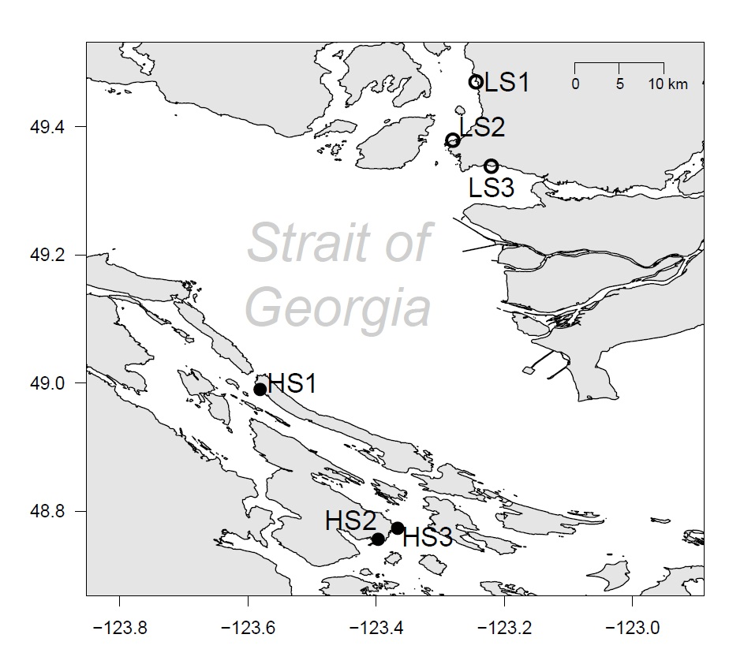

**Fig. 1** Map of the study region. Low salinity sites are located in West Vancouver and high salinity sites are located in the Gulf Islands.

*Transect Surveys*

Surveys were conducted once per month during low tide from May to August 2011, at each of the six study sites. Because the tidal range differs between the two areas, surveys were conducted at the vertical height corresponding to approximately 30% submersion time. This occurs at 2.1 m in the Southern Gulf Islands and 3.0 m in West Vancouver. Ten meters of transect tape were laid across the selected area and eight randomly selected points were surveyed using a 25x25 cm quadrat. Mobile invertebrates were counted and sessile invertebrates and algae were measured by percent cover.

*Salinity Tolerance Experiments*

i) Salinity and tidal emersion tolerance of *Lottia* spp.

To determine whether or not the salinity tolerance of limpets is influenced by the periodic emersion from hyposaline conditions experienced during low tides, we conducted a salinity tolerance experiment which incorporated a mimic of tidal exposure. Two experiments were performed, one with *L. pelta* and the other with *L. digitalis*, collected from HS1, Galiano Island, from a salinity of 32 psu. Four limpets were randomly assigned to one of twenty-four 1000 cm³ Ziploc® containers with mesh walls and two containers were randomly assigned to each of twelve 20 L aquaria containing seawater at 30 psu. Aquaria were covered, provided with compressed air and placed inside of a flow through sea water system to maintain a water temperature of 12°C. Salinity treatments of 30 psu, 20 psu and 10 psu were randomly assigned to each aquarium. Salinities were lowered by 2.5 psu per day with chilled, dechlorinated freshwater until the desired salinity was reached. To control for water changes, those treatments that had already reached target salinity were subjected to daily water replacements using filtered sea water of the target salinity in place of dechlorinated freshwater.

One randomly selected container within each aquarium was designated as the “intertidal” container, and the other as the “subtidal” container. At 10:00 every morning, the intertidal containers were removed from their aquaria to simulate exposure during low tide. At 18:00 every evening, the containers were placed back inside their aquaria. Each day, Limpets were examined for signs of mortality, including tissue damage, discolouration and rigidity, and dead limpets were removed. The experiment continued for twenty-eight days, and limpets were not fed during this time.

ii) Salinity tolerance and local adaptation of *L. pelta*

*L. pelta*, 20±5 mm in length, were collected from HS1, Galiano Island, from a salinity of 27 psu and four days later from LS3, West Vancouver, from a salinity of 10 psu. Limpets from the high salinity site were randomly divided into eighteen containers, for a total of six limpets in each. Each container was placed inside of an aquarium containing seawater at 30 psu. The salinity of the water within these aquaria was lowered by 2.5 psu per day until a salinity of 20 psu was reached. Limpets were allowed to acclimatize to this salinity for ten days. Limpets from the low salinity site were randomly divided into an additional eighteen containers, and all containers were placed into aquaria containing seawater at 10 psu, which was increased at increments of 2.5 psu per day to 20 psu. These limpets were allowed to acclimatize for six days. After the acclimatization period was complete, containers were randomly arranged into eighteen aquaria, all containing seawater at 20 psu, so that each aquarium contained one container of limpets from the high salinity site and one from the low salinity site. Aquaria were randomly assigned salinity treatments of 5, 8, 11, 14, 17 and 20 psu. Salinities were lowered at a rate of 3 psu every 30 minutes until the desired salinity was reached, and limpets remained submerged for twenty-eight days.

iii) Salinity Tolerance of *Ulva* sp.

*Ulva sp.* was collected from LS2 West Vancouver, from a salinity of 28 psu. 5-6 g of blot dried *Ulva sp*. was placed into each of sixty-four 1 L plastic bottles. Each bottle was randomly assigned a salinity treatment from 0-30 psu at intervals of 2.5 psu and provided with compressed air. The 0 psu treatment contained only distilled water, while all other treatments contained combinations of filtered seawater at 31 psu and dechlorinated freshwater at 1 psu. Bottles were placed inside of a flow through sea water system to maintain a water temperature of 12°C and provided 25±5 µmol of continuous light. After three weeks, all samples were blot dried and weighed. One sample from each treatment was randomly selected to be assessed for photosynthetic efficiency using a pulse amplitude modulation (PAM) fluorometer (Jr PAM, Heinz Walz GmbH). Light intensities were altered using a 240W Fiber Optic Illuminator (6000-1, Intralux®) and screening filters. Samples were dark acclimated for one hour before quantum yields were measured by applying a saturating light pulse after reaching a steady state. Photosynthesis vs. irradiance curves were used to determine maximum photosynthetic electron transport rate (ETRmax).

*Field Exclusion Experiments*

Seven subsites within each of the six study sites (HS1, HS2, HS3, LS1, LS2 and LS3) were manually cleared of organisms. Within each subsite, a limpet inclusion, exclusion and control plot were set. Inclusions and exclusions were formed by securing two copper fences, 2.5 cm high and 28.5 cm in diameter, to the rock face using Quickcrete® quick drying cement. Copper enclosures/exclosures of this type have been shown to be effective barriers to limpets (Harley 2002) and partial barriers to periwinkles (Harley 2006). Four *L. pelta*, 20±5 mm in diameter, were collected from the nearby shoreline within each site and placed into rings designated as limpet inclusion treatments. This density of 0.63 limpets per 100 cm², approximately corresponds to the average density of limpets in low salinity sites as determined by previous survey data (0.55 per 100 cm² in low salinity sites and 3.65 per 100 cm² in high salinity sites). *L. pelta* were determined to be the largest grazer present in the mid-intertidal in both salinity regions, and body size of grazers has been shown to positively correlate with grazing pressure (Geller 1991). Any other grazers found inside rings were removed. Limpet treatment densities were maintained every two weeks by adding or removing limpets as necessary. One circular plot within each area, also 28.5 cm in diameter, was marked with steel bolts and served as a control. The position of control and treatments was randomized within each subsite. Copper controls were not included in this study, as previous work has shown that partial copper treatments lead to partial effects which are difficult to interpret (Johnson 1992).

Sampling occurred once per month during low tide from May to August. A 10x10 cm quadrat was used to count mobile invertebrates and barnacles and estimate percent cover of algae and mussels within each treatment. Salinity samples were taken at each sampling event and measured using a refractometer (S/Mill-E, Atago Inc.).

*Statistical Analyses*

TC will update.

Salinity tolerance of *L. pelta* from experimental manipulations was determined using fixed effects ANOVA to analyze differences in the proportion of limpets surviving in each treatment and from each population on the last day of the experiment. Net productivity of *Ulva* sp. was determined as the change in biomass before and after the salinity treatments. Change in biomass and ETRmax were analyzed using least-squares regression.

**Results**

TC will edit.

*Spatial and Temporal Variation in Salinity*

Surface salinities showed a seasonal pattern across all sites, with highest salinities occurring in the winter and early spring months (October to April) and lowest salinities occurring in the summer and early autumn (June to September) (Fig. 2). Salinity in the Gulf Islands was consistently higher than in West Vancouver, and this difference was greatest in the summer months (May to August).

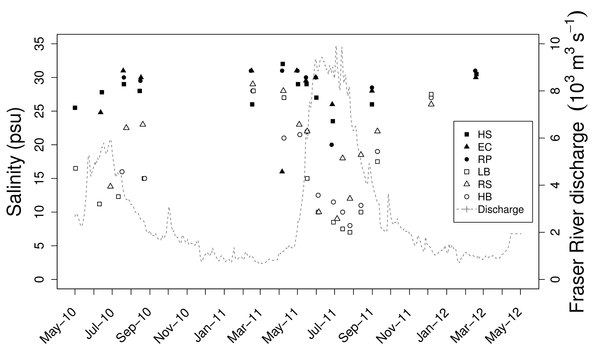

**Fig. 2** Measured surface salinity (psu) from sites in the Gulf Islands (shaded) and in West Vancouver (unshaded), British Columbia. Dashed line indicates Fraser River discharge rate (10³m³/s) measured at Hope, British Columbia (Environment Canada, 2012). Surface salinity for Eagle Cove, April 7, 2011, was influenced by heavy rainfall.

*Transect Surveys*

Ordination of samples shows differences in communities between the high and low salinity region. Differences are driven by Mytilus, Ulva, Chthamalus, Mastocarpus crust, barnacle recruits and fucus. No differences between months.

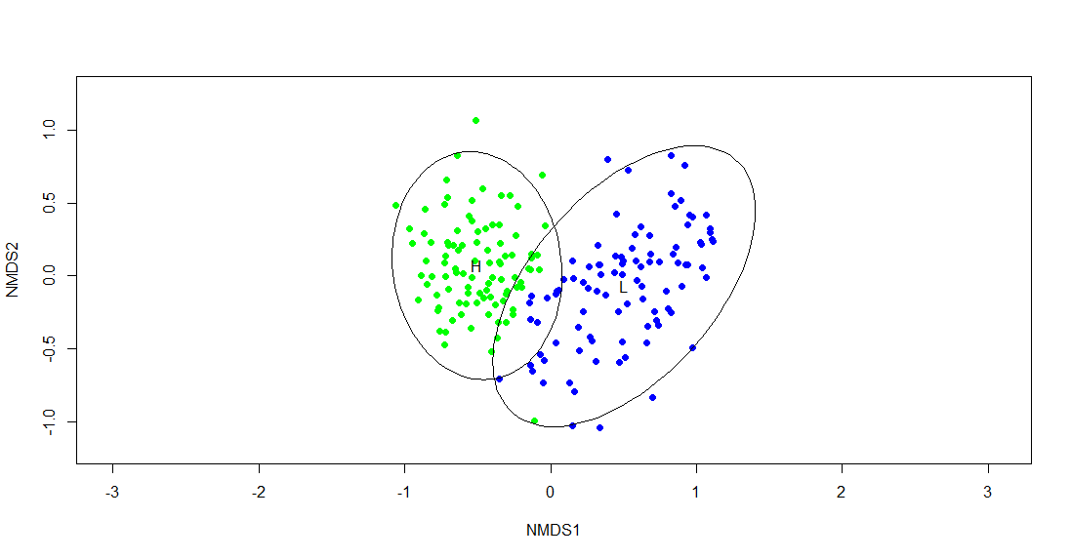

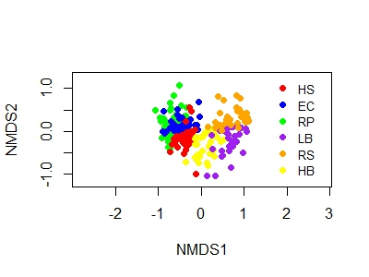

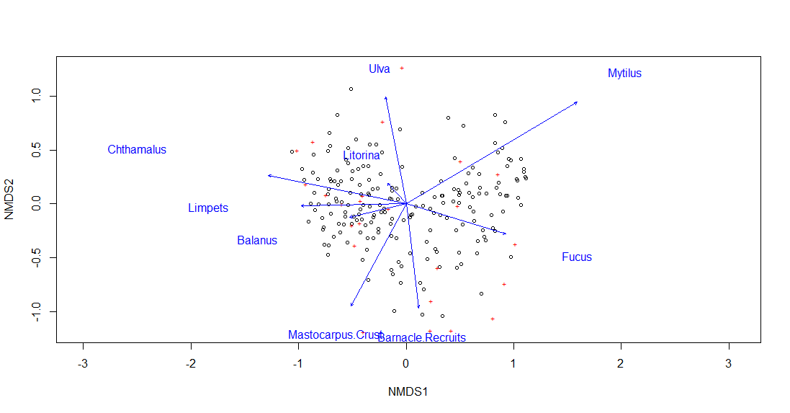

Linear mixed effect model shows significant effect of region on NMDS axis 1. Site is added as a random effect. R output below:

Linear mixed-effects model fit by REML

Data: Tdata

AIC BIC logLik

12.28096 44.43032 3.859519

Random effects:

Formula: ~1 | Site

(Intercept) Residual

StdDev: 0.2584279 0.2119923

Fixed effects: NMDS1 ~ Region + Month + Region * Month

Value Std.Error DF t-value

(Intercept) -0.4665898 0.15535185 180 -3.003439

RegionL 0.9913220 0.21970069 4 4.512148

MonthJune -0.1170840 0.06119690 180 -1.913235

MonthMay -0.0916523 0.06119690 180 -1.497663

MonthSeptember 0.0582521 0.06119690 180 0.951880

RegionL:MonthJune 0.0088155 0.08654549 180 0.101859

RegionL:MonthMay -0.0167030 0.08654549 180 -0.192997

RegionL:MonthSeptember 0.0762864 0.08654549 180 0.881460

p-value

(Intercept) 0.0030

RegionL 0.0107

MonthJune 0.0573

MonthMay 0.1360

MonthSeptember 0.3424

RegionL:MonthJune 0.9190

RegionL:MonthMay 0.8472

RegionL:MonthSeptember 0.3792

Correlation:

(Intr) ReginL MnthJn MnthMy MnthSp

RegionL -0.707

MonthJune -0.197 0.139

MonthMay -0.197 0.139 0.500

MonthSeptember -0.197 0.139 0.500 0.500

RegionL:MonthJune 0.139 -0.197 -0.707 -0.354 -0.354

RegionL:MonthMay 0.139 -0.197 -0.354 -0.707 -0.354

RegionL:MonthSeptember 0.139 -0.197 -0.354 -0.354 -0.707

RgL:MJ RgL:MM

RegionL

MonthJune

MonthMay

MonthSeptember

RegionL:MonthJune

RegionL:MonthMay 0.500

RegionL:MonthSeptember 0.500 0.500

Standardized Within-Group Residuals:

Min Q1 Med Q3 Max

-2.3251615 -0.6856838 0.1007362 0.6614641 2.5929141

Number of Observations: 192

Number of Groups: 6

Residual plot for this model:

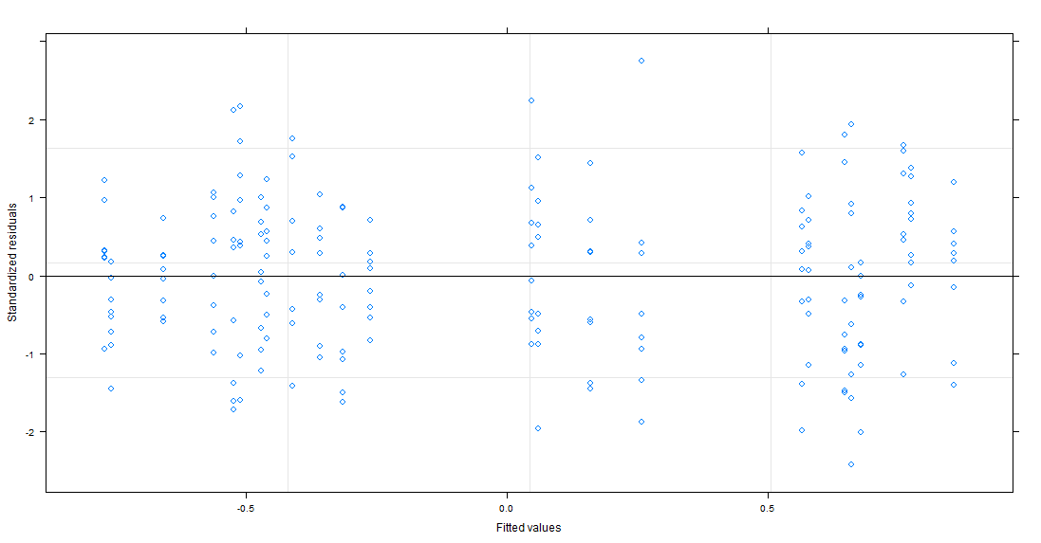

Zero-inflated negative binomial generalized linear models show significant effect of region on chthamalus, mytilus, limpets and littorina. Significant effect of month on Balanus and limpets. Significant interaction (Region*Month) for Limpets and littorina. R output for Chthamalus below:

Call:

glmmadmb(formula = Chthamalus ~ Region + Month + Region * Month +

(1 | Site), data = Tdata, family = "nbinom", zeroInflation = TRUE)

AIC: 901.4

Coefficients:

Estimate Std. Error z value Pr(>|z|)

(Intercept) 2.82e+00 6.14e-01 4.59 4.4e-06

RegionL -4.53e+00 1.00e+00 -4.52 6.1e-06

MonthJune 4.10e-01 2.69e-01 1.52 0.13

MonthMay 7.11e-02 2.71e-01 0.26 0.79

MonthSeptember -1.64e-01 2.73e-01 -0.60 0.55

RegionL:MonthJune -2.23e+01 1.79e+04 0.00 1.00

RegionL:MonthMay 4.37e-01 6.15e-01 0.71 0.48

RegionL:MonthSeptember 4.86e-01 6.00e-01 0.81 0.42

(Intercept) ***

RegionL ***

MonthJune

MonthMay

MonthSeptember

RegionL:MonthJune

RegionL:MonthMay

RegionL:MonthSeptember

---

Signif. codes: 0 ‘***’ 0.001 ‘**’ 0.01 ‘*’ 0.05 ‘.’ 0.1 ‘ ’ 1

Number of observations: total=192, Site=6

Random effect variance(s):

Group=Site

Variance StdDev

(Intercept) 1.021 1.011

Negative binomial dispersion parameter: 1.2272 (std. err.: 0.1932)

Zero-inflation: 1e-06 (std. err.: 6.6968e-08 )

Log-likelihood: -439.682

*Tolerance Experiments*

Survival of *L. pelta* from both regions was significantly greater above 11 psu than below (Fig. X; ANOVA, P<0.0001). Survival of limpets from separate regions differed significantly only in the 11 psu salinity treatment, in which limpets from the low salinity region had greater survival (Fig. Xc; ANOVA, P=0.023). There was no significant effect of tidal treatments on salinity tolerance (Fig. S2, S3).



**Fig. X** Mean proportion of *L. pelta* from the Gulf Islands (●) and West Vancouver (△) alive at each day for four of six salinity treatments (n=3). Patterns observed at 17 and 20 psu were similar to that of 14 psu. Error bars indicate standard error.

Net productivity of *Ulva* sp. was significantly affected by salinity treatment (Least-Squares Regression, R²=0.482, P<0.0001) with the greatest gain in mass at 15 psu and net losses at both 0 psu and 30 psu (Fig. Xa). ETRmax showed a similarly unimodal relationship, with a maximum value at 20 psu and minimum at 0 psu (Fig. Xb; R²=0.712).

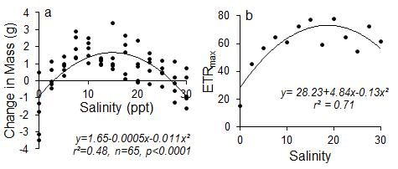

**Fig. 5** (a) Change in mass (g) and (b) ETRmax of *Ulva* sp. vs. salinity. Lines indicate least-squares regression.

*Field Exclusion Experiments*

Ordination shows grouping by month. Most variation in September.

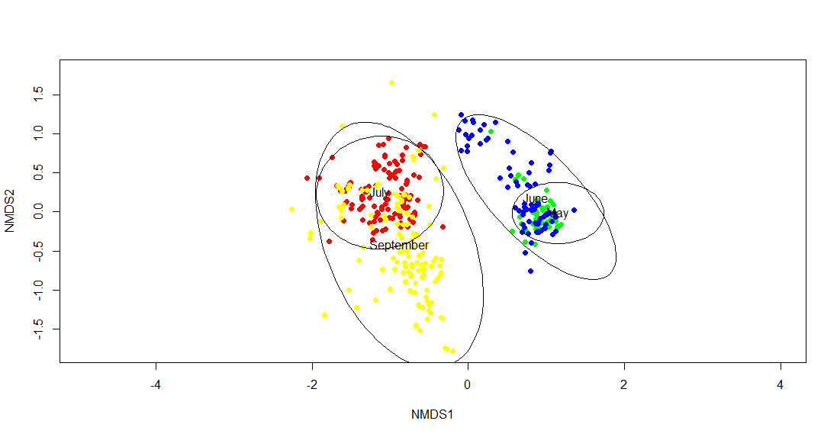

July subset shows effects of Balanus, Chthamalus, masto crust and greens (Enteromorpha).

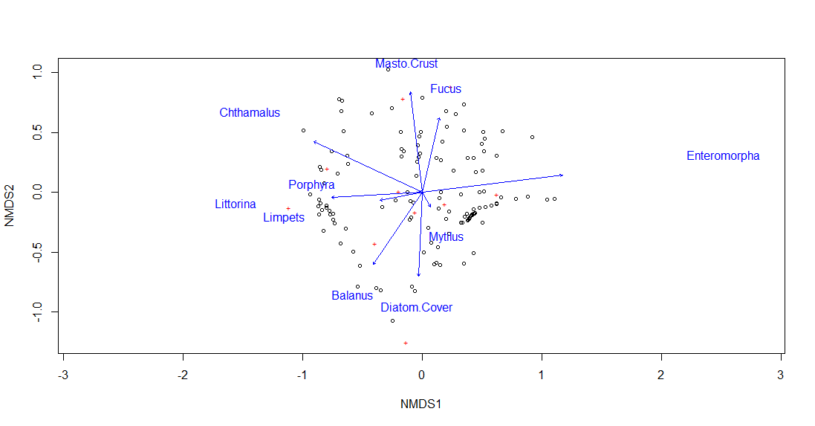

Grouping by region:

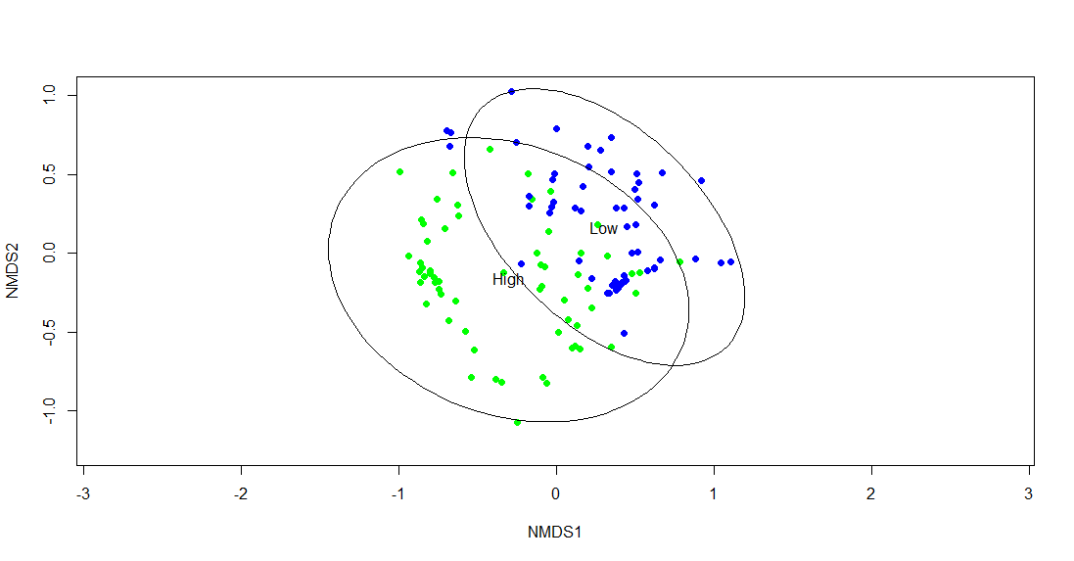

No clear grouping by treatment:

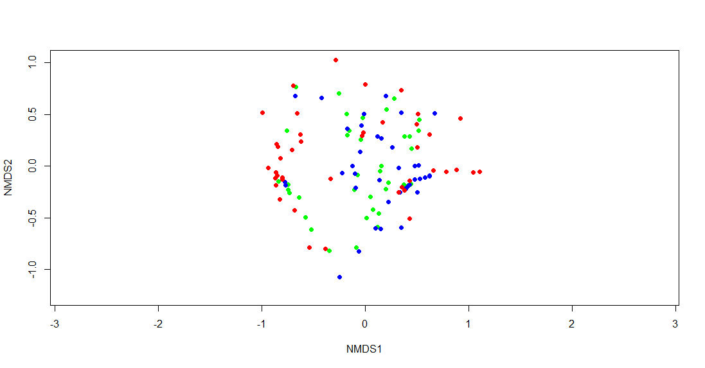

R output for linear mixed effect model on NMDS axis 1. Plot nested within site is a random effect. Significant effects of region, treatment and region*treatment:

Linear mixed-effects model fit by REML

Data: Jdata

AIC BIC logLik

102.232 127.3194 -42.11601

Random effects:

Formula: ~1 | Site

(Intercept)

StdDev: 0.2312326

Formula: ~1 | Plot %in% Site

(Intercept) Residual

StdDev: 0.1386254 0.2799769

Fixed effects: NMDS1 ~ Region + Treatment + Region * Treatment

Value Std.Error DF t-value

(Intercept) -0.6722333 0.14990214 80 -4.484481

RegionLow 1.0597530 0.21199364 4 4.998985

TreatmentE 0.7094590 0.08640274 80 8.211070

TreatmentI 0.3968315 0.08640274 80 4.592811

RegionLow:TreatmentE -0.8138136 0.12219193 80 -6.660125

RegionLow:TreatmentI -0.5446265 0.12219193 80 -4.457140

p-value

(Intercept) 0.0000

RegionLow 0.0075

TreatmentE 0.0000

TreatmentI 0.0000

RegionLow:TreatmentE 0.0000

RegionLow:TreatmentI 0.0000

Correlation:

(Intr) RegnLw TrtmnE TrtmnI RgL:TE

RegionLow -0.707

TreatmentE -0.288 0.204

TreatmentI -0.288 0.204 0.500

RegionLow:TreatmentE 0.204 -0.288 -0.707 -0.354

RegionLow:TreatmentI 0.204 -0.288 -0.354 -0.707 0.500

Standardized Within-Group Residuals:

Min Q1 Med Q3 Max

-1.84175360 -0.54274085 0.03263874 0.46732703 3.98046495

Number of Observations: 126

Number of Groups:

Site Plot %in% Site

6 42

Zero-inflated negative binomial mixed effects models shows significant effects of treatment and treatment*region on chthamalus:

Call:

glmmadmb(formula = SqChth ~ Region + Treatment + Region * Treatment +

(1 | Site/Plot), data = Jdata, family = "nbinom", zeroInflation = TRUE)

AIC: 532.8

Coefficients:

Estimate Std. Error z value Pr(>|z|)

(Intercept) 2.342 0.942 2.49 0.01292 *

RegionLow -2.550 1.405 -1.81 0.06958 .

TreatmentE -0.984 0.228 -4.32 1.6e-05 ***

TreatmentI -0.609 0.145 -4.20 2.7e-05 ***

RegionLow:TreatmentE 1.097 0.310 3.53 0.00041 ***

RegionLow:TreatmentI 0.446 0.250 1.78 0.07467 .

---

Signif. codes: 0 ‘***’ 0.001 ‘**’ 0.01 ‘*’ 0.05 ‘.’ 0.1 ‘ ’ 1

Number of observations: total=126, Site=6, Site:Plot=42

Random effect variance(s):

Group=Site

Variance StdDev

(Intercept) 2.624 1.62

Group=Site:Plot

Variance StdDev

(Intercept) 0.08291 0.2879

Negative binomial dispersion parameter: 26.678 (std. err.: 27.929)

Zero-inflation: 0.24565 (std. err.: 0.053429 )

Log-likelihood: -256.385

No significant effects on Balanus or Masto crust. Region, treatment and region*treatment significant for enteromorpha (greens):

Call:

glmmadmb(formula = Enteromorpha ~ Region + Treatment + Region *

Treatment + (1 | Site/Plot), data = Jdata, family = "nbinom",

zeroInflation = TRUE)

AIC: 173.4

Coefficients:

Estimate Std. Error z value Pr(>|z|)

(Intercept) -2.969 0.963 -3.08 0.002 **

RegionLow 2.420 1.005 2.41 0.016 *

TreatmentE 2.037 1.024 1.99 0.047 *

TreatmentI 1.108 1.111 1.00 0.318

RegionLow:TreatmentE -2.193 1.108 -1.98 0.048 *

RegionLow:TreatmentI -1.223 1.187 -1.03 0.303

---

Signif. codes: 0 ‘***’ 0.001 ‘**’ 0.01 ‘*’ 0.05 ‘.’ 0.1 ‘ ’ 1

Number of observations: total=126, Site=6, Site:Plot=42

Random effect variance(s):

Group=Site

Variance StdDev

(Intercept) 4.384e-09 6.621e-05

Group=Site:Plot

Variance StdDev

(Intercept) 5.053e-09 7.108e-05

Negative binomial dispersion parameter: 403.43 (std. err.: 1.3938)

Zero-inflation: 1e-06 (std. err.: 6.344e-08 )

Log-likelihood: -76.7163

**Discussion**

Please outline in excessive detail.

**Acknowledgements**

We would like to thank those who helped in the field; Daniel Hepler, Jocelyn Nelson, Kat Anderson, Joshua Elzam, Andres Cisneros, Kyle Demes, Rebecca Gooding, Jonathan Coyle, Steve Fuchs, Manon Picard, Gerald Singh, Jacob Uber and Darah Gibson. We would also like to thank Kyle Demes for his assistance with the PAM fluorometry experiments. This project was supported by the National Sciences and Engineering Research Council of Canada.

**References**

TC will update.